Homework 7 – Fractions Review, Ratio & Decimals

Name: __________________________________________ Date: _______________________

- Anne spent 2/3 of her money. She then lost 2/3 of the remainder and then had $4 left. How much money did Anne originally have?

- During a recent Cascade Ridge Walkathon Bob ran 50% more laps than Ram, and Ram ran 25% more laps than John. John ran 16 laps. How many laps did Bob run?

- The areas of the sectors of each of the three circles add to one. The decimal equivalent of the sum of C + I + R is closest to
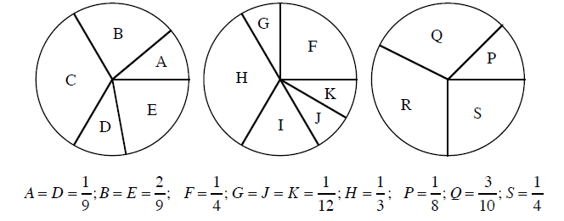

a. 0.8 b. 0.81 c. 0.83 d. 0.835 e. 0.85

- What is 0.001% of 2004?

- Tiffany walked to a school supply store and, after browsing for 8 minutes, decided to buy a pen for $1.51. Tiffany handed the salesperson $6.82 for her purchase.
How much change did Tiffany receive?
$

- On Monday, Christopher and Jessica decided to see how fast they could sprint 100 meters. They asked their friend Daniel to time them with a stopwatch. After 7.43 minutes, Daniel agreed to time the runners. Christopher sprinted first and ran 100 meters in 15.22 seconds. When it was Jessica's turn, she sped off and completed the run in 15.07 seconds. How much faster was Jessica than Christopher in seconds? seconds
- Elmer has a collection of 300 fossils. Of these, 21%, percent are fossilized snail shells. How many fossilized snail shells does Elmer have?

Fossilized snail shells
- Approximately 2% percent of the people in the world have red hair. There are about 7,000,000,000 people in the world.
About how many people have red hair?

People
Solutions:
- Working backwards …
She ended with $4, after losing 2/3 of her money.
Therefore, she had $12 before she lost her money.
Therefore, she had $12 after spending 2/3 of her money.
Therefore, she started with $36.
Answer: $36

- John ran 16 laps.
Ram ran 25% more than John, so Ram ran 16 + 25% = 16 + 4 = 20 laps
Bob ran 50% more than Ram, so Bob ran 20 + 50% = 20 + 10 = 30 laps
Answer: 30 laps

- A + D + B + E = 6/9, so C = 1/3. F + G + J + K + H = 5/6, so I = 1/6. P + Q + S = 27/40, so R = 13/40. 1/3 + 1/6 + 13/40 = 99/120 = 0.825 which rounds to 0.83.
Answer: C

- 0.001% of 2004 = 2004 x .00001 = 0.02004
Answer: 0.02004 or 0.020 (rounded off)

- To find out how much change Tiffany received, we can subtract the price of the pen from the amount of money she paid.
The amount Tiffany paid - the price of the pen = the amount of change Tiffany received.

6.82
-1.51
_____
5.31 Tiffany received $5.31 in change.
- To find how much faster Jessica was than Christopher, we need to find the difference between their times in seconds.
Christopher's time - Jessica's time = difference in times.

15.22
-15.07
_____
0.15 Jessica was 0.15 seconds faster than Christopher.

- We know that the total number of fossils (100%), is 300. We need to find out how many are fossilized snail shells, which are 21%, percent of the total.
We can first divide by 100 to see how many fossils 1%, percent would be, then multiply by 21 to see how many fossilized snail shells 21%, percent equals.
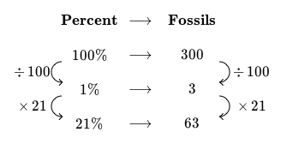
There are 63 fossilized snail shells in Elmer's collection.

- We know that the entire population of the world (100%) is equal to 7,000,000,000 people. We need to find out how many people equal 2%, percent of the world.
We can first divide the population by 100 to see how many people equal 1%, percent of the world, then multiply by 2 to see how many people equal 2% of the world.
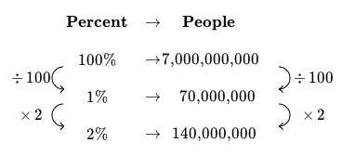
There are approximately 140,000,000 people in the world with red hair.

